Rough Draft 3 – Crowder Additions

**Color**

* History of color of maps
  + Ehrensvard 1987, Art and Cartography: Six Historical Essays
    - In early maps the information was imprecise leading to map makers choose between pictorial and abstract representation of more accurate data
  + Semiology of Graphics, Jacques Bertin 1983 Book
    - Graphically showing the difference between entities by using color
    - Goal of giving the reader of a map a clear visual indication of what is happening on the surface of the earth.
* Modern Color Selection in Maps
  + ColorBrewer.org
    - Color Schemes need to be attractive but also support the message of the map and the nature of the data
    - Color blindness
    - Thematic map data color and race

Thematic maps through history have used color to communicate activity within a geography. With early maps the information was imprecise. The imprecise nature of maps led map makers to choose between pictorial or abstract representation of more accurate data[1]. Color in early maps was more colorful than in early production maps when printed color had limited selection of color mixes. By the 19th century printing improved enough to allow to expand the role of color again [1].

The start of modern color in thematic maps can be traced to Jacques Bertin’s 1983 Book “Semiology of Graphics”. Bertin presents the goal of giving the reader of a map a clear visual indication of what is happening on the surface of the earth [2]. One way this is accomplished is through using color to show the difference between entities.

ColorBrewer developed by Mark Horrower and Cynthia Brewer in 2003 helps in choosing appropriate color schemes for mapping needs. The authors point out that choosing color schemes can be very difficult when designing thematic maps. Most GIS software does have color schemes, but they don’t provide direction on the use of color.

When a thematic is displayed on a laptop LCD it may not print the same way. The ColorBrewer system suggest color schemes if an agency needs to have the maps available through multiple media types. There is a total of 35 color schemes or sets. They are divided into three groups: qualitative, sequential and diverging. Sequential work well for when order is needed in data from low to high. Diverging colors are good for separation variables. Qualitative color schemes use differences in hue to create a set that does not imply order [3]. In opencrimemapping.org we use a diverging scheme two show the difference between residential burglaries and business burglaries on a dot map shown in figure [x]

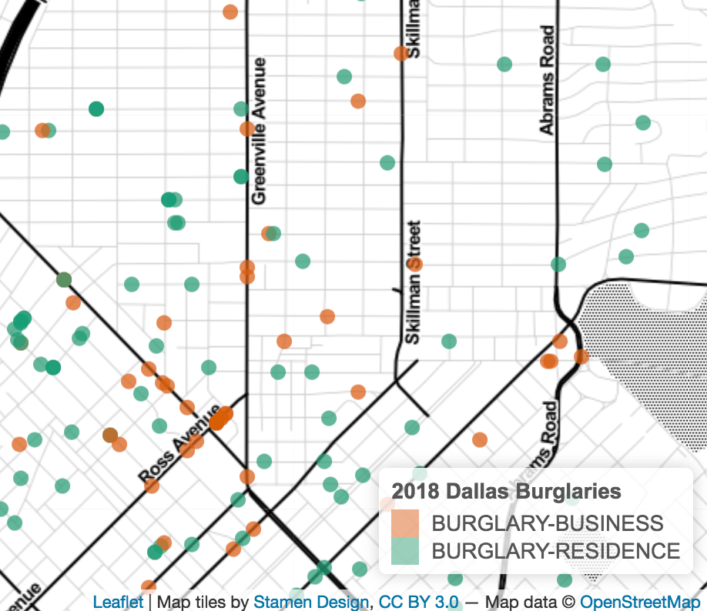

Figure [x] This dot map uses diverging colors selected from ColorBrewer.org to display different burglary types. The color selection in this map also takes advantage of ColorBrewer’s option for managing color blindness.

Colors in thematic maps also need to take into consideration. Pastel like colors were found to be more confusing to color-vision impaired users than darker colors. This is an important consideration to take into account when in a group of 25 at least one person is likely to be color-vision impaired [4].

Finally, color selection needs to take into account considerations such unintended bias. When mapping crime data using a color scheme that may match skin tones could create a perception that areas may be more heavily populated by a specific ethnicity.

It’s important that the map maker make a careful and well-thought-out choice in the data colors that are displayed on a map. Failure to do so could lead to the user not gaining new information from the map.

1. Ehrensvard, Art and Cartography: Six Historical Essays, 1987
2. Bertin, Semilogy of Graphics, 1983
3. Harrower and Brewer, ColorBrewer.org: An Online Tool for Selecting Colour Schemes for Maps, The Cartographic Journal, 2003
4. Gardner, Vision impaired map users, Evaluation of the Colorbrewer Color Schemes for Accommodation of Map Readers with Impaired Color Vision, 2005

**Interactivity**

* Cartographic interaction is the use of a digital map by a user facilitated by a computer
  + Interactive maps allow users to explore scenes dynamically to focus on areas of interest. The user is able to vary scenes with changing their scale and location spatially.
  + High levels of interactivity can enhance the user’s engagement with the observed data with their exploration abilities. This results in both learning and understanding of content.
  + How opencrimemapping.org helps to focus on areas of interest
    - Exploration in learning understanding an content

Growth in computer processing speed and Internet technologies have help lead the to the growth of interactive map availability, design and consumption. Cartographic interaction is the use of a digital map by a user facilitated by a computer. This creates a dialog between user and map.

Maps manifest themselves as knowledge from the mapmaker about the map’s variable of interest. The goal of a map whether successful or not is the transfer of geographic insight from the mapmaker to the map user [1]. In User-Centered Design for Interactive Maps: A Case Study in Crime Analysis by Roth et. al. an interactive framework for maps is presented in which focuses on the needs of the user when conceptualizing and implementing an interface [2]. This framework focuses heavily on ease-of-use. The User-Centered Design (UCD) framework is designed around three U’s.

*Usability* describes the ease of using an interface to complete the user’s objective. Opencrimemapping.org’s interface is set up from Shiny. Through Shiny we provide tools for the user to select through parts of framework. We use a drop-down button, so the user can move through periods of time easily. The user is also has the ability to pan, zoom in and zoom out with the map displayed in figure [x]. We also provide the user with the ability to hover-over specific instances. When the user hovers-over they are presented with more detailed information about the incident.

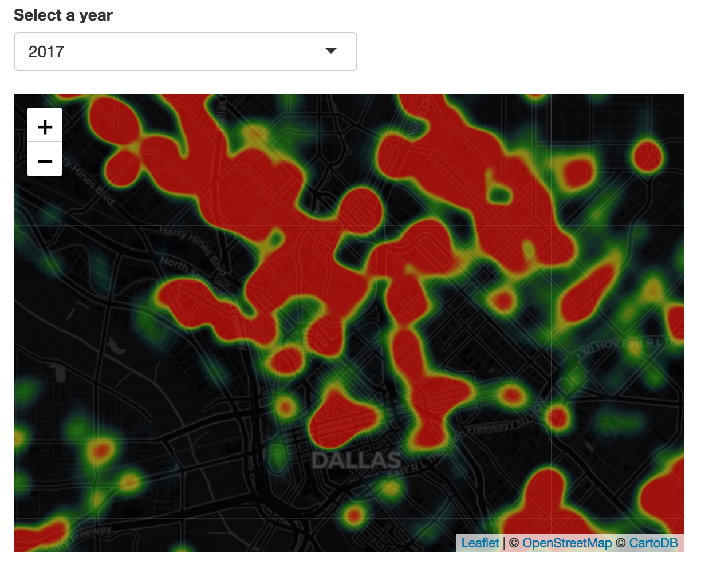

Figure [x] This heat map uses Shiny to create interactive interfaces so users can select different periods of time by selecting the drop down button on the upper right.

The usefulness of an interface for completing the user’s desired task is called *utility.* Utility taxonomy essentially breaks down to identifying one data element. Opencrimemapping.org uses color themes are well thought out to ensure a user can find data elements on a map. The second taxonomy of utility is being able to search for information through space and time to help answer “when” and “where” questions. Our tool covers utility with our framework using time-bound maps and base maps that are easy to read. Finally, to complete the UCD loop is the *user*. The targeted user is often not an expert in the field that the tool focuses on. Target user’s needs will change over time and cause an iterative process in designing a user interface. This tool did not use a formal research method to identify user needs. Instead our tool was developed through a qualitative process of trial and error with users that were not part of the tool’s development.

1. Roth, Robert, Interacting with Maps: The Science and Practice of Cartographic Interaction, 2011, The Pennsylvania State University, PhD dissertation
2. Roth et. al., User-Centered Design for Interactive Maps: A Case Study in Crime Analysis, ISPRS International Journal of Geo-Information, 2015

**Geovisualization**

* What is geovisualization
  + Roots and history
  + Difference from static maps
  + Modern technology’s effect on geovisualization
* How our tool demonstrates geovisualization principals
  + Interactivity
  + Knowledge

Geovisualization is deeply rooted in traditional cartography which has been around for thousands of years in human history. Geovisualization is the visualization of geospatial information to create human understanding that leads to data exploration and decision making [1].

Traditional maps known as static maps are simply fixed images. These maps can be produced on traditional mediums such as hardcopy, like books, atlases and magazines. They can also appear online as images on websites in file formats such as Portable Network Graphic (PNG), Joint Photographic Experts Group (JPEG), Portable Document Format (PDF), etc. Interactive maps allow the user to zoom in and out, hover-over popups, etc. to engage data and find underlying patterns in greater depth. Interactive maps are produced and viewed on computers.

Some early work in geovisualization can be traced back to the term geographic visualization by the National Science Foundation in 1987. If we go back a decade earlier, we find that Jacque Bertin presented design principals for presenting cartographic and information design to explore data [2]. The International Cartographic Association (ICA)created a Commission on Visualization in 1995 to stimulate geovisualization research and encourage interdisciplinary research to create highly interactive, exploratory methods to initiate knowledge construction. The ICA now has the Commission on Visual Analytics to support geovisualization1 which was formed in 2015. This commission focuses on interactive visualizations that can support knowledge construction and insights from spatial data in forms that are both big and small2.

Modern information availability has helped lead to an explosion of geovisualization tools. These tools can be found not only in our opencrimemapping.org tool for mapping crime, but in search for real estate in applications such as Zillow and Realator.com. There are numerous private companies using geovisualization as revenue driver. Perhaps the best known is Google’s Maps Platform. Google’s Map Platform has over one billion monthly active users and gets 25 million updates a day3. Google sells their platform to companies to display information spatially. Government agencies use geovisualization for military, forestry, fishery, demographic and economic data display for both internal and external communication.

Opencrimemapping.org uses geovisualization as a tool of interactivity so users can gain knowledge of criminal activity in their areas to construct insights. The maps have the ability for users to hover-over, zoom and out, base map layer selection, time selection, variable selection and color selection for knowledge construction.

Website Footnotes

1. <https://viz.icaci.org/category/commission-updates/>
2. <http://regionalequityatlas.org/toolkit/overview-of-static-and-interactive-maps>
3. <https://cloud.google.com/maps-platform/maps/>

References

1. Jang, B., Li, Z., Geovisualization: Design, Enhanced Visual Tools and Applications, The Cartographic Journal, 2005
2. MacEachern et. al., Geovisualization for Knowledge Construction and Decision Support, IEEE Computer Graphics and Applications, 2004

**Time**

Time or temporal analysis in maps has been in use with thematic maps for many years. Like space, time is heterogeneous [1]. We see day differences in terms of weekdays and weekends. The analysis of spatiotemporal data can be complex with many numbers of distinct planes. This can cause in the example of a dot map to display too much information and leaving the user with no knowledge to be gained from the map. To help with this interactive maps should be time bound. Users of opencrimemapping.org are able to switch between time periods to obtain knowledge.

Time in most visualization methods is considered linear. Most visualizations that incorporate time do so based on a timeline [2]. Actions in time can occur in cycles. With burglaries in Dallas weekdays display higher densities of instances than on weekends.

In crime mapping victims, offenders, and property managers adjust densities over time around specific places. Using the drop down to select different years on our tool the user can see differences in density as displayed in figure [x].

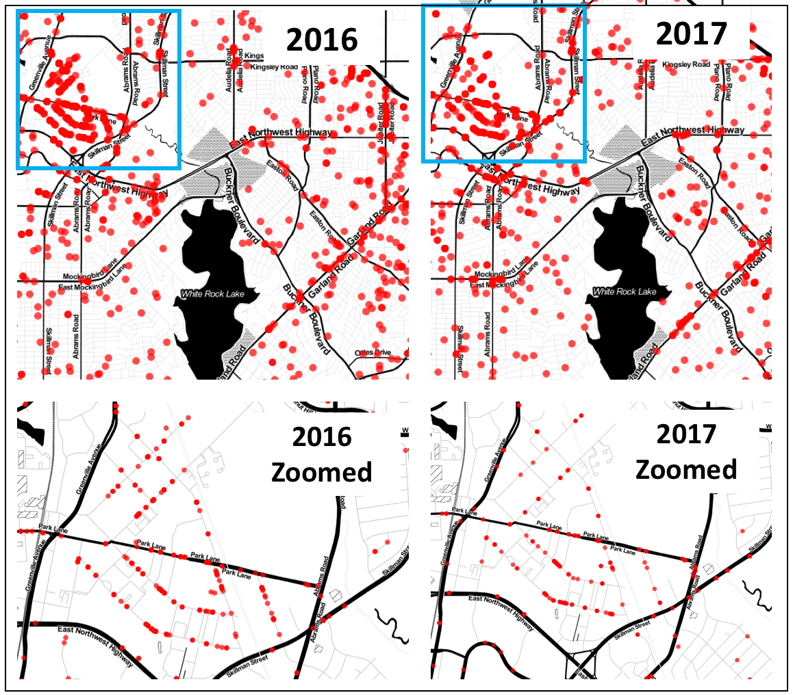

Figure [x] This dot map has been zoomed in a location in Dallas with a high density of burglaries. Using the drop-down button the user is able to see the difference in density from one year to the other.

The user can recognize that less burglaries happened in 2017 verse prior year in 2016.

References

1. Andrienko et.al. Space-in-Time and Time-in-Space Self-Organizing Maps for Exploring Spatiotemporal Patterns, Eurographics/ IEEE-VGTC Symposium on Visualization, 2010
2. The Time Wave. A New Method of Visual Exploration of Geo-data in Time-space, The Cartographic Journal, 2008

**Ethical Considerations – NOT STARTED**

The dataset we use in this paper contains the names and addresses of complainants of the burglaries displayed in this research. We did not map out the addresses of the complainants of the burglaries, there was no reason to do so. The practice of including the name and address of the complainant is actually very common in public safety open datasets. Unwarranted publication of personal addresses could pose a threat to those that report crimes. There also inlies the possibility of businesses scraping the data of complainants to target advertisements and products in what could be a sensitive time for the complainant.

The “Incident Address” in our data is the address where an incident occurred. There exist many possible ways in which data can be displayed on maps. Heat maps present opportunities to adjust density in order to magnify the visualization of incident location. This could cause the potential for an area to appear to have more activity than it actually does. If a user of the geovisual tool is looking at say crime in an area they are considering purchasing a house, or a user is looking for a place to place a business the density on the heat map could turn that user away from an otherwise safe area.

Those preparing geovisualization for novice users should take into account potential considerations on how the visualization could affect an individual party, or a community as a whole. A famous case of geovisualization in journalism occurred in 2012 just months after the Sandy Hook Elementary shooting [Craig, 2017]. The publication published three online maps that contained a two-county area with the names and addresses of those that were permit holders.

Some ground-rules, or guidelines to consider when preparing a geovisualization for novice users would be to research data journalism guidelines. Craig, Ketterer, and Yousuf, in their paper “To Post or Not to Post: Online Discussion of Gun Permit Mapping and the Development of Ethical Standards in Data Journalism provides some recommended frames when considering publishing information that could raise ethical questions. The first is *freedom verus responsibility and journalistic purpose*, which purposes that data should not be posted only because its already in a public dataset. The second frame is *privacy and verification,* to attempt to measure the risks to a person’s private life. Thirdly are *consequences* to the individual if the information is wrong. Finally, what *alternatives* are available, such as showing trends or joining with other data to tell the same story [Craig, 2017].